University of Virginia Health System

Medical Laboratories

“Quality You Expect, Service You Deserve”

LABORATORY MEDICINE UPDATE
January 15, 2018

Contract Medications Urine Samples for Drugs of Abuse Testing

The process for submitting urine samples for drugs of abuse testing to maintain chain of custody include sealing the urine cup in the presence of the patient with red tamper resistant tape. When placing the tape on the urine cup please do not tape over the patient registration label on the cup. The laboratory needs to be able to read the registration label clearly. See the picture below for proper placement of the label and the tamper resistant tape.
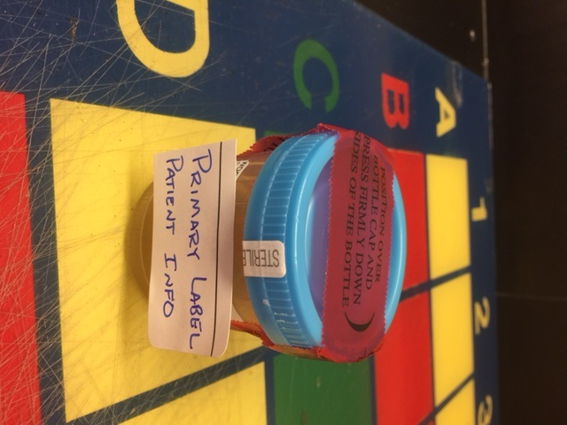

Microsatellite Instability Analysis via PCR and Capillary Electrophoresis
As of January 1, 2018, the Clinical Genomics Laboratory is performing microsatellite instability (MSI) analysis in house. These samples were previously sent to Mayo Laboratories for analysis. MSI may be present in patients with colorectal and endometrial tumors at risk for Lynch Syndrome. These patients may require less aggressive therapy than patients with MSI-negative tumors. In addition, the FDA has recently approved the use of pembrolizumab for treatment of all unresectable metastatic solid tumors positive for MSI. Early detection of MSI status helps guide treatment decisions in these patient populations.
Required specimen: Formalin-fixed paraffin embedded tissue blocks and paired H&E slides that contain both tumor and normal tissue. An anatomic pathologist will examine the slides and circle separate areas of tumor and normal tissue for comparison of microsatellite alleles. Minimum tumor percent: 40%.
Testing Schedule: MSI analysis will be performed on an as-needed basis. Turnaround time is 14 days.
Please contact the Clinical Genomics Laboratory with questions at 4-6290.
OncoScan Microarray for FFPE specimens: Genome-wide copy number variation detection
The Cytogenetics Laboratory will begin offering the OncoScan Microarray assay on February 1, 2018. This assay allows for the genome-wide detection of copy number variation (CNV), i.e. deletions or duplications of genetic material, in DNA derived from formalin-fixed paraffin-embedded (FFPE) specimens. The OncoScan Microarray will also detect genome-wide loss of heterozygosity (LOH), as well as some high frequency somatic mutations,74 mutations in nine genes (BRAF, KRAS, EGFR, IDH1, IDH2, PTEN, PIK3CA, NRAS, TP53).Copy number variation plays a critical role in a variety of solid tumors, including gliomas, melanomas, renal cell carcinomas, and others. The ability to detect CNVs genome-wide from FFPE specimens will complement UVA’s existing next generation sequencing-based assays to offer complete mutation detection (both sequence variation and copy number variation) in clinically relevant genes. Turnaround time for results is 14 to 21 days from receipt with results available in EPIC.
Required specimen: formalin fixed paraffin embedded tumor tissue block. A matched H&E will be examined by an anatomic pathologist who will circle the area of interest and determination the percent tumor load. Minimum tumor load: 40%

CMV Viral Load Analysis by the Abbott m2000 RealTime CMV Test
As of January 8, 2018, the Clinical Microbiology and Molecular Diagnostics Laboratory has implemented a new method for CMV viral load analysis. The new Abbott m2000 RealTime CMV test provides an expanded dynamic range: from 50 IU/mL to 156,000,000 IU/mL as compared to 137-3,000,000 IU/mL reported previously. Viral load values are generally comparable between methods, with a slight positive bias observed with the new Abbott method. Contact the Microbiology Laboratory Director to discuss any need for a new baseline value for your patients. In general, the Abbott method provides better precision and analytical sensitivity at the lower end of the linear range.
Results will read as follows:
- For patients with a viral load at or above the limit of quantification of 50 IU/mL, a numeric value and the log base 10 will be reported.
- For patients with no measurable viral load, the result “None Detected” will be reported.
- For patients with a detectable but not quantifiable viral load, the results “Virus detected, but quantified at less than 50 IU/mL and less than 1.70 log base 10” will be reported. This indicates that CMV nucleic acid is present, but at a level below the limit of quantification.

Required specimen: Approved specimen type has not changed. Testing requires EDTA-anticoagulated plasma (pink top tube). Required volume is 5 mL blood (1 mL plasma minimum).
Testing Schedule: CMV viral load testing will be performed Mondays, Wednesdays, and Fridays, with additional runs performed as needed to meet the requirements of the current patient caseload.
Please contact the Clinical Microbiology Director on call at PIC 1221 with questions.

Minimum Residual Disease (MRD) Determination/Mutant NPM1 Detection via Reverse Transcriptase Real-Time PCR
As of February 1, 2018, the Clinical Genomics Laboratory will offer NPM1 MRD analysis on blood and bone marrow samples as an investigational use only test. Mutant NPM1 gene expression can be used as a marker in a subpopulation of acute myeloid leukemia patients to determine treatment efficacy/failure. Analysis requires previous demonstration that the patient carries a specific known tetranucleotide insertion in the NPM1 gene. Previous analysis of a pretreatment sample is required.
Note: This is currently an investigational use only test. Clinical utility is unclear at this time and results should be interpreted with consideration of the overall clinical presentation. Please contact the Clinical Genomics Director for more information.
Required specimen: EDTA-anticoagulated blood or bone marrow sample. Pink-top collection tube preferred. Minimum blood/bone marrow requirement: 3 mL. Specimens should be transported to the Genomics laboratory in a timely manner following collection as this test utilizes RNA and sample extraction must occur within 72 hours of collection.
Testing Schedule: NPM1 MRD analysis will be performed on an as-needed basis and requires Clinical Genomics Laboratory Director approval prior to analysis. Turnaround time is 14 days.

Special Coagulation Test Orders
To allow optimal evaluation and interpretation of the tests listed below, a PT (Prothrombin Time) and/or APTT/PTT (Activated Partial Thromboplastin Time) will be added to the order. In some instances, an abnormal PT or APTT will indicated that the tests below need not or should not be performed.
- PT Mixing Study
- PTT Mixing Study
- Lupus Anticoagulant Panel: dRVVT, SCT and Staclot
- Protein C
- Protein S

Factor XIII Assay
The quantitative Factor XIII assay is now available in-house.
The test code in EPIC is FAXIII and the test will replace the Miscellaneous Send-out – Factor XIII
Testing will be performed Monday-Friday 7:00 AM - 3:30 PM or with Pathology approval (page 1663) on evenings, weekends and holidays.
FXIII is essential for maintaining hemostasis due to its role in fibrin stabilization and in the protection of fibrin from proteolytic degradation by the fibrinolytic system

Reminder: Proper Blood Collection for Light Blue Top Tubes
Specimen Requirements:
- Preferred sample: 3 mL light blue top (3.2% Sodium Citrate)
- Alternate sample: 2 mL light blue top (3.2% Sodium Citrate)
- To achieve proper blood to anticoagulant ration, the MINIMUM acceptable blood volume is the etched line on the BD vacutainer tube.
- No clotted, moderately or hemolyzed specimens are acceptable.
- Transport light blue top at room temperature

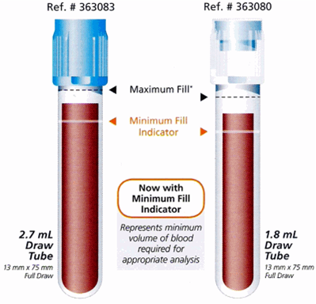

Corrected Heparin Level – change to report
An additional field will be observed in the patient record to indicate whether or not the DOAC (Direct Oral Anticoagulant/Interfering Anticoagulant) is present.
If present (Yes), the Corrected Heparin Level should continue to be ordered.
If not present (No), the Heparin Level should be ordered.

