To All Medical Laboratory Users:  This edition of the Lab Med Update has the following articles:  - New: Genomics Solid Tumor Expanded NGS Panel, Pg. 1-2  if you have an article(s) you would like to share CONTACT:  - Terri Workman Proffitt  - 434-924-5198  - EMAIL:  - Twp3q@virginia.edu |  |   MEDICAL LABORATORIES  Laboratory Medicine Update  May – June 2020  New: Genomics Solid Tumor Expanded NGS Panel  Effective June 1, 2020, the Genomics lab will be offering a 148-gene panel for the detection of DNA variants (i.e. single nucleotide variants, multinucleotide variants, insertions/deletions) in common solid tumors including lung, colon, gastric and ovarian tumors, and melanoma. Gene content is provided below. The 26-gene TruSight Tumor panel has been discontinued by the vendor and will no longer be offered.  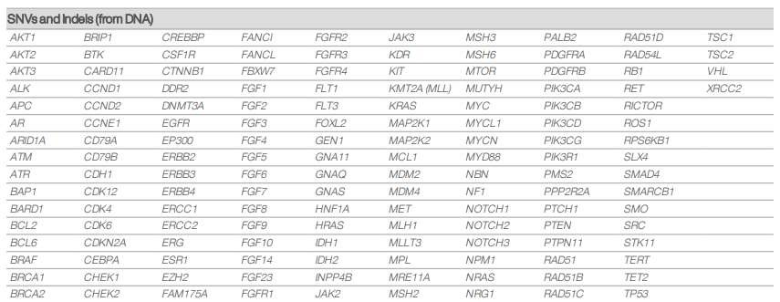  The test name in EPIC is “Genomics Solid Tumor Expanded NGS Panel.”  The Solid Tumor Expanded Panel tests all genes currently covered by the TruSight Tumor panel, while allowing more comprehensive molecular profiling through an expanded gene list. Additionally, the new test has demonstrated improved performance with limited biopsy material compared to the existing TruSight Tumor panel.  Required Specimen: Approved specimen types are FFPE tissue with matched H&E slide. Slide should be submitted for pathology review and marked to indicate area containing tumor tissue. Sample and slide should be accompanied with a completed test request form listing percent tumor.  Schedule: The Solid Tumor Expanded Panel will be performed once weekly, consistent with the current TruSight Tumor schedule. Specimens must be received in the Clinical Genomics Laboratory by noon on Monday to be included in weekly analysis. Specimens received after this deadline will be held for analysis the following week. The transition to the Solid Tumor Expanded Panel will not result in a change in turnaround time for solid tumor NGS testing. Reports will continue to be available approximately 8 days after specimen batching.

