To All Medical Laboratory Users:  This edition of the Lab Med Update has the following articles:  - Platelet Function Test (LAB318)  - Changes to Urine Specimen Collection containers  if you have an article(s) you would like to share CONTACT:  Terri Workman Proffitt  434-924-5198  EMAIL:  Twp3q@virginia.edu |  |   MEDICAL LABORATORIES  Laboratory Medicine Update  November 2019  Platelet Function Test (LAB318)  Beginning in November, 2019, the Platelet Function Test (LAB318) will only be available Monday – Thursday 7:00 am – 10:00 am. Specimen requirements may be found in the EPIC Procedure Catalog. (see below)  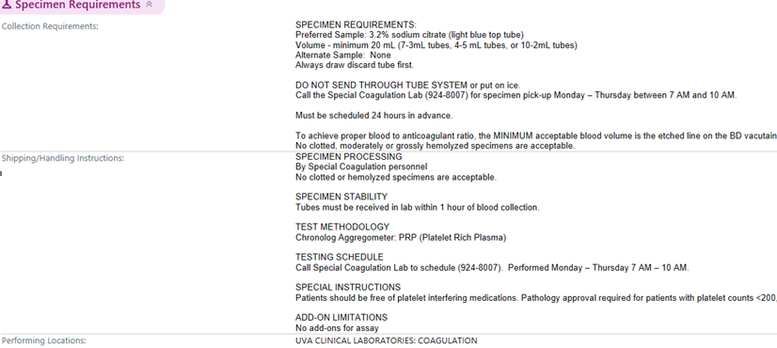  Changes to the Urine Specimen Collection Containers  Effective November 12, 2019, there will be changes to the Urine Specimen Collection containers. This change is an initiative driven by the CAUTI coalition in collaboration with the Medical Laboratories to preserve specimen integrity. National recommendations for urine collection and specimen handling suggest the use of containers with preservatives if the specimen cannot be transported and plated on culture medium within 2 hours of collection. This will prevent bacterial overgrowth in the collection container which could lead to inaccurate results and treatment.  This change will apply to many, but not all urine specimens. A Tip sheet is included for what container should be used for specific Laboratory testing.

