University of Virginia Health System

Medical Laboratories

“Quality You Expect, Service You Deserve”

LABORATORY MEDICINE UPDATE
May 17, 2017

CA 27.29 Test Change at Mayo Medical Laboratories
On May 14, 2017, the highest reportable value for CA 27.29 from Mayo Medical Laboratories changed to 450 U/mL.
This change is due to notification from the assay manufacturer that the diluent required to extend the reportable range is no longer available. Results greater than 450 U/mL will be reported as >450 U/mL. The prior reportable range was up to 9,000 U/mL.

Please consider utilizing Cancer Antigen 15-3 (CA 15-3), available 24/7 from UVA Medical Laboratories as an alternative tumor marker. Re-baselining of and parallel testing are available at no charge to your patient. Contact the Clinical Chemistry Director on-call (pic 1657) to discuss.

Change in Blood Transfusion Consent Requirements
The length of time a Blood Transfusion Consent is valid has changed effective 4/1/17.
- A new transfusion consent must be obtained for each inpatient hospitalization.
- A transfusion consent is valid only throughout a single inpatient hospitalization or 6 months, whichever is shorter.
- In the case of ongoing administration of blood or blood components in an outpatient setting, informed consent must be obtained at a minimum every six months.

Please call the Blood Bank at 924-2273 with questions.

Benzodiazepine Urine Drug Screen
The Medical Laboratory performs screening of urine for drugs of abuse and automatically reflexes positive samples for confirmation. Because the screen assay for benzodiazepines can miss low concentrations of the drug, we have seen false-negative results. To address this issue the laboratory has established an indeterminate range for benzodiazepines. If a sample falls within this range, then the screen result will be reported as “Indeterminate, refer to confirmation results” and the sample will be reflexed for benzodiazepine confirmation. If you get a negative screen result on a patient under contract for benzodiazepine and believe the patient is compliant with their treatment program please contact the Toxicology Laboratory (924-2029) to add on the confirmation test.

Proper Collection of Blood Samples for Quantiferon Gold TB
The Medical Laboratory offers a blood-based assay to detect exposure to Mycobacterium tuberculosis. The collection kit contains three unique tubes – grey top, red top, and purple top – and they are not interchangeable with routine collection tubes that have the same colored tops. The vacuum of these tubes is manufactured to collect 1 mL of blood with a range of 0.8 – 1.2 mL. Each tube has a black line on the label to serve as a guide when collecting blood. Over-filled and under-filled tubes are not acceptable for analysis and will lead to the test being cancelled. Once the tubes are filled it is important to shake them firmly ten times to ensure the entire inner surface of the tube is coated. When placing a specimen label on the tube please leave a “window” so the sample can be seen. Refer to the pictures below.
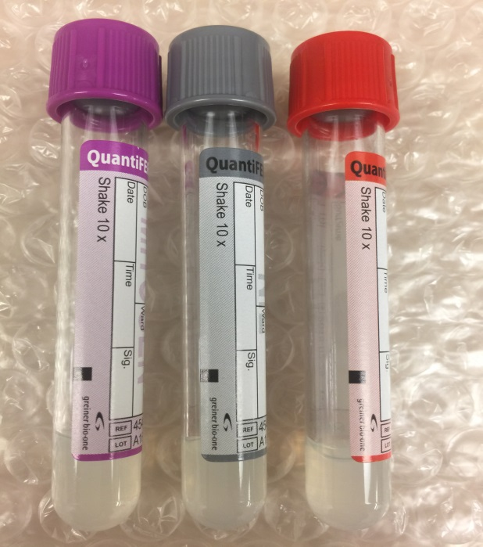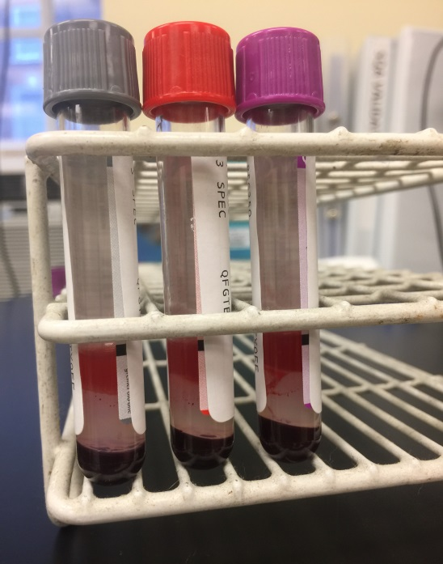
Empty tubes with black fill line on label Labeled tubes with clear view of sample

