University of Virginia Health System

Medical Laboratories

“Quality You Expect, Service You Deserve”

LABORATORY MEDICINE UPDATE
January 16, 2017

Reminder: Correct Order of Draw – Different for venipuncture versus Skin Puncture

The correct order of draw/fill of blood tubes is critical to reducing pre-analytical errors for laboratory testing. The correct order for venipuncture versus skin puncture is provided below as a reminder.

Venipuncture:
- Blood Culture Bottles
- Blue (sodium citrate)
- Red top (no anticoagulant)
- Gold top SST (serum separator)
- Tiger Top SST (silica clot activator serum separator)
- Light Green (lithium heparin gel separator)
- Dark Green (sodium heparin)
- Lavender/Pink (K-EDTA)
- Gray (sodium fluoride, potassium oxalate)
- Anything else

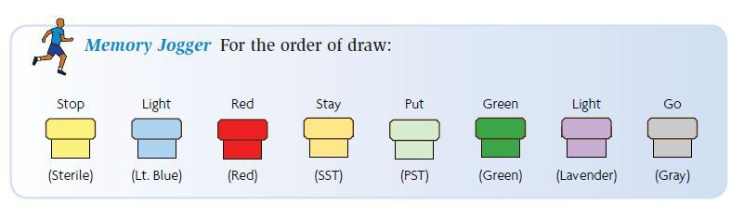

Skin puncture such as a heel stick or finger stick:
- Lavender (K-EDTA)
- Light Green (lithium heparin gel separator)
- Any other additive tube
- Gold SST (serum separator)

Hypersensitivity Pneumonitis Panel
The Medical Labs offers one assay for Hypersensitivity Pneumonitis, which is sent to Mayo. The method is Immunoassay FEIA and includes IgG to Alternaria tenuis / alternata, Aspergillus fumigatus, Aureobasidium pullulans, Micropolyspora faeni, Penicillium Chrysogenum / notatum, Phoma betae, Thermoactinomyces vulgaris, Trichoderma viride. The Epic test name and number is listed in the global and preference list as Hypersensitivity Pneumonitis Panel LAB4208. The in-house hypersensitivity profile and aspergillus assay by immunodiffusion has been discontinued.

Methylmalonic Acid
The Toxicology Laboratory is now performing methylmalonic acid in-house twice a week. The assay is performed by liquid chromatography tandem mass spectrometry (LC-MS/MS) and is beneficial in evaluating children with signs and symptoms of methylmalonic acidemia or individuals with signs and symptoms of vitamin B12 deficiency. The assay requires 1 gold top tube and is performed on serum. The reference interval is <0.4nmol/mL.

