University of Virginia Health System

Medical Laboratories

“Quality You Expect, Service You Deserve”

LABORATORY MEDICINE UPDATE
March 4, 2016
Retrieval of Miscellaneous Send Out Results in Epic
A new process has been implemented to more rapidly provide results received by FAX from reference laboratories (including the State Lab) to the EMR. Directions for the new process are to click on Chart Review and then Labs tab. A scanned result will have the paperclip icon next to it.
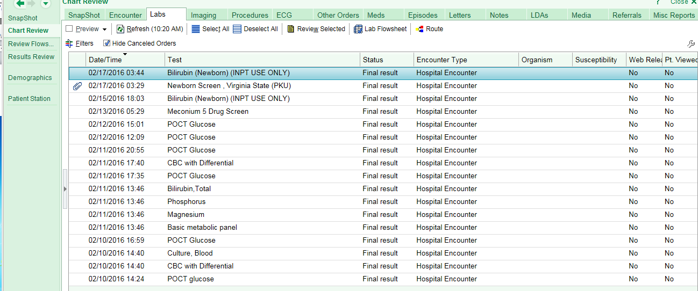
Click once and the result will open up. If “Results” is not apparent, scroll down and then click on the line below. This will automatically open the document without the need to search through “Scanned Documents”

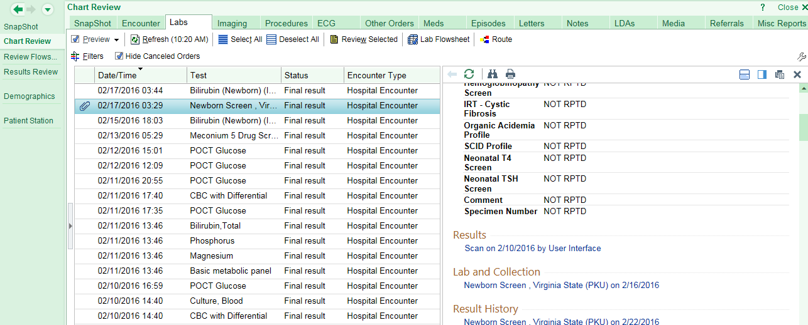
Click here to open the document
Glucose Critical Value change
The Patient Care Committee has approved a change in the critical value for glucose. For patients greater than or equal to 28 days of age, results of greater than 600 mg/dL are considered critical and will be called to the ordering physician.
“Timed” Blood Draws
The phlebotomy team has an established window of time to obtain blood draws requested for a specific time. Please be aware that timed blood draws should be limited to drug levels, direct admit labs, and tests that might be affected by treatment. The established window is the requested time ± 30 minutes for drug levels and ± 60 minutes for other tests. This is a quality metric tracked by UVA Medical Laboratories and we are currently at approximately 80% compliance.

It is not appropriate to use the “timed” function for routine laboratory tests. Ninety percent of requests for “morning draws” at 0600 are completed on all inpatients by 0730 with results available by 0845. When the phlebotomy team is tasked with multiple timed draws for Basic Chemistry and CBC’s, these goals are not met, affecting multiple areas of patient care.

MLH1 Hypermethylation Analysis by PCR and PyroSequencing
On February 5, 2016, the Molecular Diagnostics Laboratory began offering analysis to detect hypermethylation of the MLH1 gene, a component of the DNA mismatch repair (MMR) system. Defects in MMR are associated with multiple malignancies including ~25-30% of endometrial and colorectal carcinomas. The clinical concern is in identifying the few (about 5% of cases), but clinically relevant situations of familial cancer syndromes associated with MMR deficiency (i.e. Lynch Syndrome). This requires significant genetic testing and counselling as Lynch Syndrome is associated with an increased risk of subsequent cancers or familial cancer predisposition. Cancers associated with Lynch Syndrome typically do not exhibit MLH1 hypermethylation.

However, the majority of cases with MMR deficiency are due to hypermethylation of the MLH1 promoter region, which are typically sporadic events.

In conjunction with the MLH1 assay, we perform an analysis of the BRAF gene, targeting the V600E mutation. The presence of the BRAF V600E mutation is almost always associated with MLH1 hypermethylation and essentially rules out Lynch Syndrome.

This assay targets five CpG methylation sites in the promoter region of MLH1.
Methodology: Bisulfite treatment of genomic DNA isolated from FFPE tissue, PCR of a segment of the MLH1 promoter region, and pyrosequencing on the Qiagen PyroMark Q24 system.
Required specimen: formalin fixed paraffin embedded tumor tissue block. A matched H&E with the area of interest circled must accompany each sample. Determination of percent tumor load is also required; ideally a minimum of 40%.
Drugs of Abuse Confirmations
The Medical Labs Toxicology division performs urine drugs of abuse screening (UDS) with automatic reflex to specific drug confirmations if the screen result is positive. The UDS ordering options are as follows:
- Drugs of Abuse, Full Screen: includes Amphetamines, Barbiturates, Benzodiazepines, Cannabinoids, Cocaine, Ethanol, Opiates, Oxycodone, Phencyclidine, Methadone, Methadone Metabolite (EDDP) and integrity checks pH, specific gravity, creatinine.
- Drugs of Abuse, Modified Screen: same as above but without ethanol.
- Urine Contract Med Screen: same as the Full Screen. Reserved for patients who have signed a drug pain contract and are required to be monitored regularly.
Most of the specific drug confirmation assays are now orderable in Epic (see below) with the exception of the following drug classes: Benzodiazepines, Barbiturates, Phencyclidine, Buprenorphine and Fentanyl. We are currently updating these confirmation assays and once they are complete they will also be orderable in Epic. Please note that specimen integrity testing (pH, specific gravity, creatinine) is only available with a urine drug screen order and will not be performed if only a confirmation assay is ordered
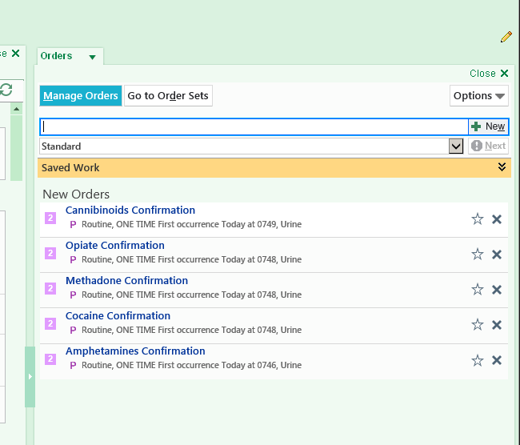

New Test Orders Available for Pediatric Blood Cultures
To ensure the use of the appropriate blood culture bottle collection on pediatric patients, two new test orders will soon be available in Epic. There are no changes to blood culture orders for adult patients.
Epic Order: Pediatric Blood Culture
- To be used for isolation of aerobic bacteria and/or yeast
- Please collect pediatric yellow cap blood culture bottle only.
- 0.5-4 ml is optimal collection volume for pediatric bottle.
- May use either charcoal or resin-containing yellow cap bottle
Epic Order: Pediatric Blood Culture w/Anaerobic
- To be used only when anaerobic bacteria are suspected.
- Please collect pediatric yellow cap bottle (as above) and an adult anaerobic (purple cap) bottle.
- 5-10ml is optimal collection volume for anaerobic bottle.
Please contact the Clinical Microbiology Director on call at PIC 1221 with questions or comments.

