University of Virginia Health System

Medical Laboratories

“Quality You Expect, Service You Deserve”

LABORATORY MEDICINE UPDATE
October 21, 2015
Next Generation Sequencing (NGS) Illumina TruSight Myeloid Panel
The Medical Laboratories began offering the TruSight Myeloid Sequencing Panel on October 1, 2015. This assay provides a comprehensive assessment of 54 genes (tumor suppressor genes and oncogenic hotspots) known to be frequently mutated in hematological malignancies, focusing on leukemia and myeloproliferative disorders (MDS – AML continuum).
The panel features a highly optimized oligo pool that focuses on ~141 kb of genomic content, consisting of 568 amplicons of ~250 bp in length designed against the human NCBI37/hg19 reference genome. The oligo pool targets 15 full genes (exons only) plus exonic hotspots of an additional 39 genes, providing nearly 100% coverage of all targeted regions.
ABL1 | CALR | CSF3R | FLT3 | IDH2 | KRAS | NRAS | RUNX1 | STAG2
ASXL1 | CBL | CUX1 | GATA1 | IKZF1 | MLL | PDGFRA | SETBP1 | TET2
ATRX | CBLB | DNMT3A | GATA2 | JAK2 | MPL | PHF6 | SF3B1 | TP53
BCOR | CBLC | ETV6/TEL | GNAS | JAK3 | MYD88 | PTEN | SMC1A | U2AF1
BCORL1 | CDKN2A | EZH2 | HRAS | KDM6A | NOTCH1 | PTPN11 | SMC3 | WT1
BRAF | CEBPA | FBXW7 | IDH1 | KIT | NPM1 | RAD21 | SRSF2 | ZRSR2
The test is available in Epic under Genomics Trusight Myeloid Panel (see below) and is approved for peripheral blood or bone marrow specimens collected in EDTA (lavender top tube). Manual orders on the Bone Marrow Test Request Form will also reflex to this new assay. Turnaround time for results is 14 days from receipt and will be reported via CoPath and available in Epic.
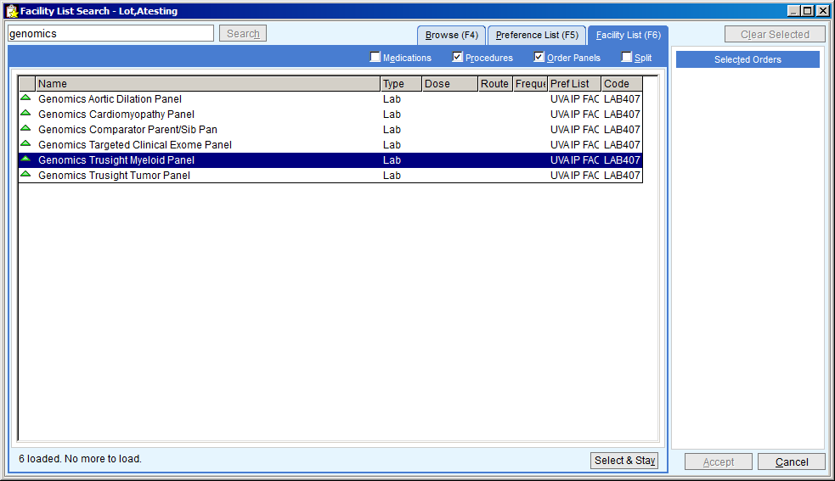
Chronic Granulomatous Disease (CGD) by Flow Cytometry
The stability of EDTA (purple top) specimens for CGD is up to 4 hours after collection. Specimens need to be in the Davis Laboratory by 2:00pm in order to be analyzed the same day. We are unable to accommodate testing after 2:00pm so patients with afternoon clinic appointments will need to be rescheduled or be provided a collection request for another day, preferably in the morning.
Steroid Testing Discontinued
The Medical Laboratories Toxicology division has discontinued offering anabolic steroid testing as of October 1, 2015.
Change in Reporting Urine Drugs of Abuse Confirmation Results
Beginning November 1, 2015 the Toxicology Laboratory will report quantitative confirmation results for cannabinoids (THC), benzoylecgonine (cocaine metabolite), methadone and methadone metabolite (EDDP); all other drug confirmation results will continue to be reported qualitatively until on-going development and validation work has been completed. Any positive urine drug screen performed by the Toxicology Laboratory is reflexed to confirmation using either gas chromatography- mass spectrometry or liquid chromatography-tandem mass spectrometry. If the specimen has a concentration equal to or greater than the established drug cutoff concentration it will be reported as a quantitative result with an interpretation of positive. If the specimen has a concentration less than the established drug cutoff concentration the interpretation will be negative. Specific drug concentration cutoff values are:
- THC: <15 ng/mL
- Cocaine: <50 ng/mL
- Methadone: <100 ng/mL
- Methadone Metabolite: <100 ng/mL
Please note: specimens with a positive urine drug screen result are reported with the comment Refer to Confirmation Result and therefore should not be acted upon until the confirmation is verified. Please contact the Toxicology Laboratory Director, Lindsay Bazydlo, Ph.D., if you have any questions.
Urine Drugs of Abuse Screening
The Urine Drugs of Abuse screen performed in the Toxicology Lab reports qualitative results for several drug classes with positive results reflexed to confirmation. There are limitations in what drugs can be detected by screen.
- Benzodiazepine: Negative results can be seen with patients taking clonazepam (klonopin), lorazepam (ativan) and midazolam.
- Opiates: Negative results can be seen with patients taking hydrocodone (vicodin, lortab, norco) and hydromorphone (dilaudid).
- Opiates: Positive results can be seen with patients taking oxycodone (oxycontin, roxicodone).
In House Serum Viscosity Testing Discontinued
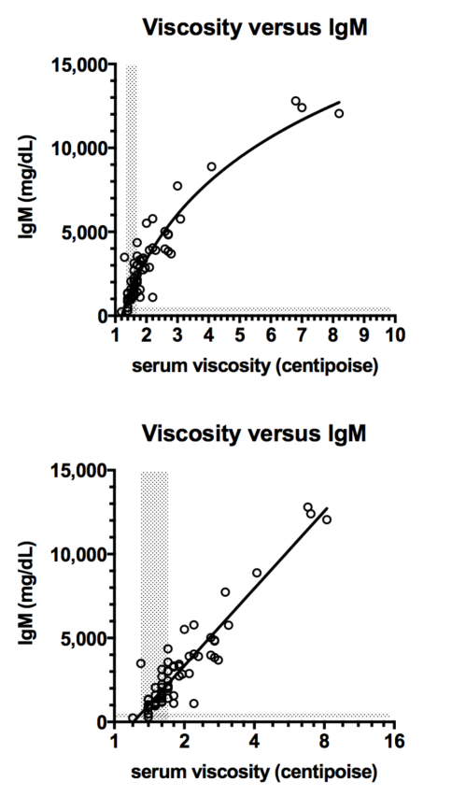
Since 1974, the Blood Bank has been using a manual technique to perform serum viscosity. The supplies required for this testing are no longer commercially available, and the laboratory will soon be unable to support this assay with current equipment.
The serum viscosity is one factor that goes into the clinical decision to initiate plasma exchange (PLEX) for patients with Waldenstrom’s Macroglobulinemia (WM) who present with acute symptoms of hyperviscosity, due to high levels of serum immunoglobulin, which are almost always of the IgM subtype. Other criteria used to make the decision to initiate PLEX in WM include serum IgM levels, and clinical symptoms.
Data from our own laboratories, collected over the last two years, show that there is a strong correlation between serum IgM and serum viscosity values (see graph) in WM, such that the two laboratory measurements could perhaps be used interchangeably in the context of WM and PLEX.
At a recent Hematology/Oncology Tumor Board Meeting, Dr. Gorham presented the concerns about the current UVA serum viscosity assay, and suggested the possibility that clinicians use the IgM serum level as the primary laboratory test, along with symptoms, to initiate plasma exchange.
The Heme/Onc physicians agreed to the discontinuation of the serum viscosity assay at UVA. While serum viscosity will not be routinely ordered, if it is needed, the test can be ordered as a send-out through Mayo Laboratories, with a turnaround time of two business days.

Availability of Unrestricted Flu Testing
The Clinical Microbiology Laboratory will begin offering unrestricted influenza testing by rapid PCR on October 28, 2015. Until that time, approval for testing can be requested by contacting the Clinical Microbiology director on call at PIC 1221.

