University of Virginia Health System

Medical Laboratories

“Quality You Expect, Service You Deserve”

LABORATORY MEDICINE UPDATE
January 21, 2015

Change to Rotem Testing Schedule
Effective 1/25/2015, Rotem testing will be performed 24/7. The testing is performed in the Blood Bank and samples can be sent in the pneumatic tube station. Do NOT send Rotem testing samples to the Core Lab.
Due to the increased availability of Rotem testing, PT/PTT testing by the blood bank will be discontinued. All requests should be sent to the Core Lab.

New Order Screens for Fecal Fat (aka Stool Lipids) Requests
Please note that there is a single Epic order screen for fecal fat requests that now prompts the ordering clinician for the time of collection. This is required information for both UVA Medical Laboratories and Mayo Medical Laboratories where the analysis is performed.
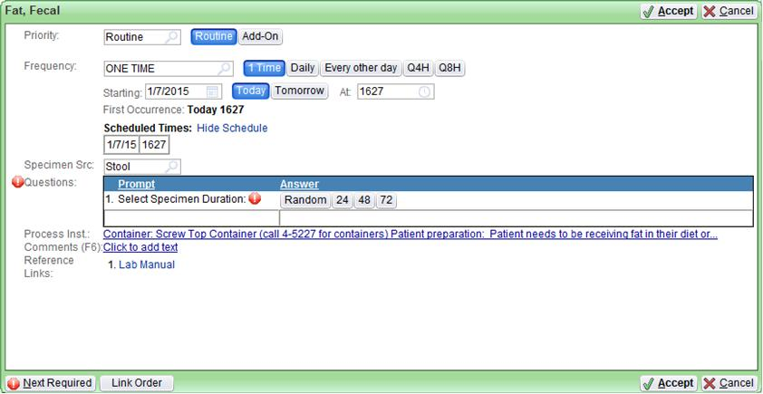

Multiple Myeloma Workup
The suggested laboratory workup for possible multiple myeloma now includes serum free light chain analysis (free kappa, free lambda, and calculated kappa/lambda ratio) in addition to serum protein electrophoresis (SPEP) and quantitative immunoglobulins. The detection of an abnormal band on SPEP or an abnormal serum free light chain ratio (free kappa/free lambda) will reflex to immunofixation. The presence of a serum monoclonal protein by immunofixation should be followed by a random urine sample for urine protein electrophoresis (UPEP) and, if an abnormal band is detected, will reflex to immunofixation. Patients found to have light chain multiple myeloma should be followed by 24 hour urine collections for quantitative light chain analysis.

Sterile Body Fluids Should no longer be Inoculated into Blood Culture Bottles at the Bedside
Effective immediately, the laboratory report for Sterile Body Fluids sent in blood culture bottles will include a comment stating that accepting these specimens inoculated into bottles at the bedside will be discontinued on July 1, 2015. After that date, the Clinical Microbiology Laboratory will begin cancelling cultures of sterile body fluids (other than blood and bone marrow) that have been inoculated into blood culture bottles anywhere other than in the Clinical Microbiology Laboratory. Problems with volume inconsistencies, the inability to perform gram stains on the original specimen, and the inability to accurately quantify organisms has led us to the conclusion that this practice should be discontinued at the bedside. Please be assured that appropriate specimens will be inoculated into blood culture bottles and tested according to best practices by the Clinical Microbiology staff. Sterile body fluids should be submitted in a sterile, leak-proof cup or tube only. Clinical Microbiology will evaluate the specimens received, and will inoculate standardized amount of specimen into blood culture bottles when appropriate. In the interest of best patient care, it is our hope that clinicians will begin sending body fluids in sterile leak-proof containers immediately. Blood and bone marrow samples are exempt from this policy and should continue to be sent per the current practices.
Please contact the Clinical Microbiology Director on Call at PIC 1221 with questions or concerns.

